Welcome to Historic Salem UCC in Columbia, PA!

Thank you for joining us in worship today. We hope that no matter who you are or where you find yourself on life’s journey, you will find welcome and warmth here!

In our Order of Worship Bold Words invite all to read out loud in unison.
Please feel free to stand during our hymns and recitations, or to sit if you are more comfortable. Worship is for you, and your comfort is important to us.

If you have a pastoral need or want to talk, please contact Pastor Mark Harris by email: uccmcharris@gmail.com.
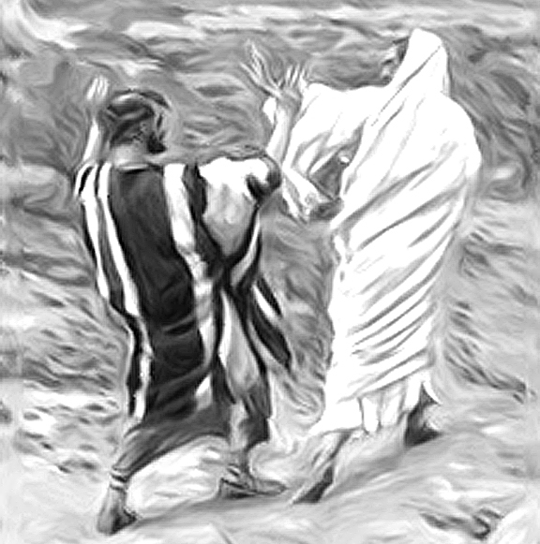
James Tissot, Get Thee Behind Me, Satan!, 1886
Sunday Worship at Historic Salem Church
February 28, 2021
Second Sunday of Lent
Order of Worship
Bell Ringing
Announcements
Call to Worship (Leader/People)
Welcome human of every shape and nature.
In your diversity you reflect your divine Creator.
All are welcome here.
Only all of us together can represent the great multiplicity and beauty
Of the entire Body of Christ.
All of us together, no matter who we are, or where we are on our journeys.
Come join us as we strive to discern what is human, what is divine,
And to what if any degree there is any difference.
Come, for all are welcome to join us in worship.

Invocation
*Opening “”Take Up Your Cross,” the Savior Said” B # 204

Prayer of Confession (Leader/People)
As humans, we have a penchant for categorizing things.
These plants belong in this bed, and these in another.
These are my business emails, and these my personal ones.
These are my close friends, and these my acquaintances.

But natural wisdom has shown us that some unlike plants grow well together.
What happens to your email boxes when you begin to date someone you met at work?
How quickly it is in hard times that ones who are our closest friends reveal themselves.

When we decide for God what is human and what is Divine,
God have mercy.

When we insist on the Divine Christ, and forget the Humanity of Jesus,
Jesus have mercy.

When we see the difference between Divine and Human as an unclimbable wall,
Rather than the calm pool between the two, able to be waded and swum in by all,
Lord have mercy.
Assurance of Grace

Passing the Peace: May the peace of the Lord be with you. And also with you.
*Hymn “Meta Prayer” SPP # 32
Bible Reading Romans 4:13-25 Pew Bible, NT p. 155
Gospel Reading Mark 8:31-38 Pew Bible, NT p. 44
Message
*Hymn “Let Us Hope when Hope Seems Hopeless” B # 461
Pastoral Prayers, and Lord’s Prayer
Our Father, who art in heaven, hallowed be thy name. Thy kingdom come. Thy will be done on earth as it is in heaven. Give us this day our daily bread, and forgive us our debts as we forgive our debtors. And lead us not into temptation, but deliver us from evil. For thine is the kingdom, and the power, and the glory, forever. Amen.
Acknowledgement of the Gifts of the Body of Christ
Offertory
*Blessing the Gifts (together)
Holiest of Holies, may the words of our mouths,
And the meditations of our hearts,
The prayers of our souls,
And the desires of our bodies,
The Divine within us, and the Humanity we embody,
Be acceptable to you, our Rock and our Redeemer. Amen.

*Congregational Thanksgiving “We Praise You, O God” B # 420 v. 3
With voices united, our praises we offer, and gladly our song of thanksgiving we raise. Our sins now confessing, we pray for your blessing; to you our great Redeemer, forever be praise!
*Sending Hymn “Growing In Faith” SPP # 169
*Benediction
*Threefold Amen Amen, Amen, Amen
Procession of the Light

Historic Salem UCC Announcements for February 28, 2021
324 Walnut Street (P.O. Box 429) Columbia, PA 17512
Phone: 717-684-6498; email: salemucc.columbia@gmail.com;
Web: https://www.historicsalemucc.org/
Pastor: Mark Harris Executive Council Chair: Peggy Rupp
Exec. Cncl Co-Chair: Scott Bollinger Music Facilitator: Steve Spiese
Financial Secretary: Karen James Church Secretary: Peggy Spiese
This Week’s Coming Events
Sunday, every 10:15 – 11:15 am Worship Service with Children’s Message
Holy Communion every first Sunday of the month
Wed, March 3 6:00-7:00 pm Yoga in the Ed Building - All are welcome!!
Altar flowers are placed in honor of Michael James birthday by Karen James.

Yoga Classes: 6:00 – 7:00 pm on Wednesday evenings in the Education Building. The cost is $5 per class, offered by Jen Hollinger to beginners or others who haven’t practiced yoga recently. Bring a yoga mat or towel, water and plastic bands if you have them.
February Mission of the Month – Sanctuary Roof Repairs. Indicate your gift on the memo line of your check, marking it “Mission of the Month.”

March Mission of the Month – One Great Hour of Sharing. The theme this year is “Water is life. Water is love. Let love flow.” With your support, 100 families will benefit from the Water Well project, sponsored by the United Church of Christ in Mozambique (UCCM). When you give to One Great Hour of Sharing, you invest in the hopeful future of women and girls around the world and serve as co-workers with God to build a just world for all.
Salem UCC's Christmas Eve Service continues to be available online at www.HistoricSalemUCC.org and our facebook page at https://www.facebook.com/salemucc.columbia

Open/Close – Scott and Denise Bollinger (Volunteers are needed for these tasks
Ushers - Scott and Denise Bollinger If you would like to help,
Teller - please contact Karen James)

