Welcome to Historic Salem UCC in Columbia, PA!
Thank you for joining us in worship today. We hope that no matter who you are or where you find yourself on life’s journey, you will find welcome and warmth here!

In our Order of Worship Bold Words invite all to read out loud in unison.
Please feel free to stand during our hymns and recitations, or to sit if you are more comfortable. Worship is for you, and your comfort is important to us.

If you have a pastoral need or want to talk, please contact Pastor Mark Harris by email: uccmcharris@gmail.com.
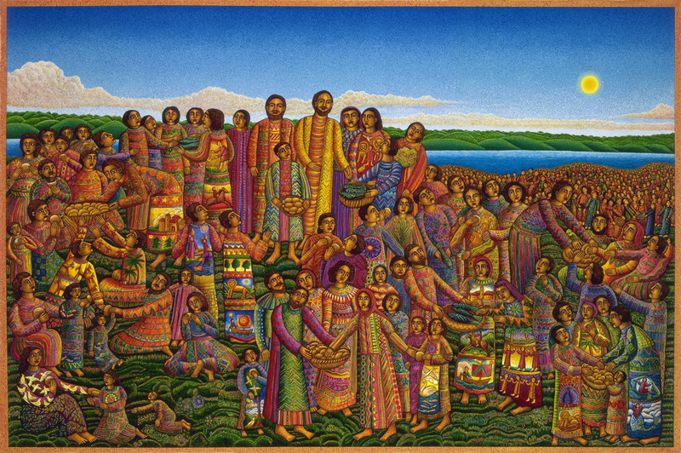
Loaves and Fishes, John August Swanson, 2003 (see back for details)
“For many years I sketched, and tried to work out in my imagination, how the scene of the LOAVES AND FISHES, with its multitude of people, could be painted. I wanted this image to honor native peoples in many parts of the world; those who work the land for their livelihood, and have lived for generations in small communities or villages...
The people in my painting are wearing garments with many colors and patterns, inspired by the creations of the makers of cloth, the weavers, and the dyers of Central America, Mexico, and parts of Africa and India...
My image of LOAVES AND FISHES emphasizes and reminds us of the basic needs of all humanity. We all share the need for food and for providing for our families and communities. If we take the cosmic view, that there currently exists enough of what we need to sustain the world; we urgently need to consider sharing the resources that have been entrusted to us.”
JOHN AUGUST SWANSON makes his home in Los Angeles, California, where he was born in 1938. He paints in oil, watercolor, acrylic and mixed media, and is an independent printmaker of limited edition serigraphs, lithographs and etchings.
Sunday Worship at Historic Salem Church
July 25, 2021
Order of Worship
Bell Ringing & Announcements
Call to Worship (Leader/People)

We join together as hungry eaters
to be nourished by the food that you offer us.
God of sustenance, give us this day our daily bread.

As you care for the wheat fields that turn into bread
and the vineyards that labor to produce sweet wine,
tend to our bodies by feeding us what we need for healthy growth.
God of abundance, give us this day our daily bread.

The rich crops that you have prepared are now ready
to be harvested by our hands and our hearts.
Holy Spirit, come! Give us this day our daily bread.

Invocation
*Opening “Joyful, Joyful, We Adore You” B # 4

Prayer of Confession
Assurance of Grace (together)
Though at times we fail to be generous,
your generosity toward us is never-ending!
By sending Christ and the Spirit to your people,
you have extended generosity beyond measure.
Let us now do the same by greeting each other with a sign of peace.

Passing the Peace: May the peace of the Lord be with you. And also with you.
Hymn “Come to the Banquet” SPP # 8
Bible Reading 2 Kings 4:42-44 Pew Bible, OT p. 336
Gospel Reading John 6:1-21 Pew Bible, NT p. 97
Message
*Hymn “You Have Come down to the Lakeshore” B # 173
Pastoral Prayers, and Lord’s Prayer
Our Father, who art in heaven, hallowed be thy name. Thy kingdom come. Thy will be done on earth as it is in heaven. Give us this day our daily bread, and forgive us our debts as we forgive our debtors. And lead us not into temptation, but deliver us from evil. For thine is the kingdom, and the power, and the glory, forever. Amen.
Acknowledgement of the Gifts of the Body of Christ
Offertory
*Blessing the Gifts (together)
God of wonders, who enabled Jesus and Elisha to feed the multitudes,
bless these gifts and use them to fill empty stomachs and empty hearts.
May our offerings be multiplied to abundantly nourish all the people.
*Congregational Thanksgiving “We Praise You, O God” B # 420 v. 3
With voices united, our praises we offer, and gladly our song of thanksgiving we raise. Our sins now confessing, we pray for your blessing; to you our great Redeemer, forever be praise!
*Sending Hymn “We Are All One” SPP # 121
*Benediction
*Threefold Amen Amen, Amen, Amen
Procession of the Light
“Food for All”: Service Prayers for the Ninth Sunday after Pentecost was written by the Rev. Kristina Lizardy-Hajbi, Iliff School of Theology, Denver, CO. ©Copyright 2021, Faith INFO Ministry Team, United Church of Christ, 700 Prospect Avenue, Cleveland, OH 44115-1100. Permission granted to reproduce or adapt this material for use in services of worship or church education. All publishing rights reserved.
Historic Salem UCC Announcements for July 25, 2021
324 Walnut Street (P.O. Box 429) Columbia, PA 17512
Phone: 717-684-6498; email: salemucc.columbia@gmail.com;
Web: https://www.historicsalemucc.org/
Pastor: Mark Harris Executive Council Chair: Peggy Rupp
Exec. Cncl Co-Chair: Scott Bollinger Music Facilitator: Steve Spiese
Financial Secretary: Karen James Church Secretary: Peggy Spiese
This Week’s Coming Events
Sunday, every 10:15 – 11:15 am Worship Service with Children’s Message
11:15-Noon Fellowship Hour (bring goodies to share)
Wed, July 28 6:00-7:00 pm Yoga in the Ed Building - All are welcome!!
Thurs., July 29 7:00-9:00 pm NA Meeting in Ed Building
Altar flowers are placed in loving memory of Fritzi Henry’s birthday, by her daughter, Karen.

Yoga Classes: 6:00 – 7:00 pm on Wednesday evenings in the Education Building. The cost is $5 per class, offered by Jen Hollinger to beginners or others who haven’t practiced yoga recently. Bring a yoga mat or towel, water and plastic bands if you have them.
July Mission of the Month – Columbia Life Network – This month, we are collecting a special offering for the Columbia Life Network. The Columbia Life Network is a central non-profit that coordinates services for those in need in the Borough and surrounding area who helped to start Fresh Express, and provide resources to prevent eviction, and for residents to gain access to needed services.

Open/Close – Denise and Scott Bollinger (Volunteers are needed for these tasks
Usher - Denise and Scott Bollinger If you would like to help,
Teller - please contact Karen James)

