Welcome to Historic Salem UCC in Columbia, PA!

Thank you for joining us in worship today. We hope that no matter who you are or where you find yourself on life’s journey, you will find welcome and warmth here!

In our Order of Worship Bold Words invite all to read out loud in unison.
Please feel free to stand during our hymns and recitations, or to sit if you are more comfortable. Worship is for you, and your comfort is important to us.

If you have a pastoral need or want to talk, please contact Pastor Mark Harris by email: uccmcharris@gmail.com.
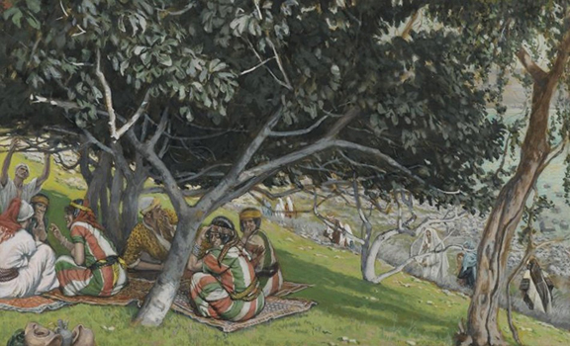
Nathanael Under the Fig Tree, James Tissot, 1886
Sunday Worship at Historic Salem Church
January 17, 2021
Order of Worship
Bell Ringing
Announcements
Call to Worship (Leader/People)
Most Holy and Gracious God . . .
. . . Let us welcome all in Your Holy Name:
Welcome to all!
Invocation
*Opening Hymn “One in Christ” SPP # 27

Prayer of Confession (Leader/People)
Last week when we recalled our baptisms,
We remembered that we are called as Christians to renounce evil.
Not just to cease to commit evil acts, but to speak out against evil as well.
The Irish Statesman Edmund Burke said,
“The only thing needed for evil to prevail is for good men to do nothing.”
These days, speaking out against evil might seem like a full-time job.
But is that accurate? Is it worse now, and if so,
Is it perhaps because we have failed to speak out clearly and loudly enough in the past?

When we keep quiet about the evil we encounter,
When we fail to speak out for justice for our brothers and sisters in Christ,
When we mistake hangman’s nooses, high-capacity magazines, and pipe bombs,
When we allow degrading each other and questioning each other’s humanity,
When all of these become our way of discussing the direction of our society:

God have mercy, Lord have mercy, Christ have mercy on us.
Assurance of Grace

Passing the Peace: May the peace of the Lord be with you. And also with you.
Due to current recommendations to maintain physical distance, we ask that the Passing of the Peace be observed through gestures and words, rather than hugs and handshakes.
*Hymn “Jesus Calls Us, o’er the Tumult” B # 172
Bible Reading Psalm 139 Pew Bible, OT p. 577
Scripture Reading John 1:43-51 Pew Bible, NT p. 92
Message
*Hymn “Like a Mother Who Has Borne Us” B # 583
Pastoral Prayers, and Lord’s Prayer
Our Father, who art in heaven, hallowed be thy name. Thy kingdom come. Thy will be done on earth as it is in heaven. Give us this day our daily bread, and forgive us our debts as we forgive our debtors. And lead us not into temptation, but deliver us from evil. For thine is the kingdom, and the power, and the glory, forever. Amen.
Acknowledgement of the Gifts of the Body of Christ
Offertory
*Blessing the Gifts (together)
Lord let these gifts come together
As we must come together
If we are to discern and carry out the will of Our God,
And the teaching of our Jesus,
Amen.
*Congregational Thanksgiving “We Praise You, O God” B # 420 v. 3
With voices united, our praises we offer, and gladly our song of thanksgiving we raise. Our sins now confessing, we pray for your blessing; to you our great Redeemer, forever be praise!
*Sending Hymn “All My Days” SPP # 84
*Benediction
*Threefold Amen Amen, Amen, Amen
Procession of the Light

Historic Salem UCC Announcements for January 17, 2021
324 Walnut Street (P.O. Box 429) Columbia, PA 17512
Phone: 717-684-6498; email: salemucc.columbia@gmail.com; Web: https://www.historicsalemucc.org/
Pastor: Mark Harris Executive Council Chair: Peggy Rupp
Exec. Cncl Co-Chair: Scott Bollinger Music Facilitator: Steve Spiese
Financial Secretary: Karen James Church Secretary: Peggy Spiese
This Week’s Coming Events
Sunday, every
10:15 – 11:15 am Worship Service with Children’s Message
Wed, January 20
6:00-7:00 pm Yoga in the Ed Building - All are welcome!!
Gift Card for Mike Fry – who has been working hard to get the heat working as well as working on the electric box located in the boiler room. We are very grateful for Mike’s knowledge and skill and willingness to do this work for free. If you would like to contribute to a gift card for Mike, please place your donation in the offering plate by January 24 and mark as thank you gift to Mike.

Yoga Classes: 6:00 – 7:00 pm on Wednesday evenings in the Education Building. The cost is $5 per class, offered by Jen Hollinger to beginners or others who haven’t practiced yoga recently. Bring a yoga mat or towel, water and plastic bands if you have them.
January Mission of the Month – Homes of Hope. You can show your love by indicating on the memo line of your check, marking it “Mission of the Month.”

Salem UCC's Christmas Eve Service continues to be available online at www.HistoricSalemUCC.org and our facebook page at https://www.facebook.com/salemucc.columbia

Open/Close – Karen James (Volunteers are needed for these tasks
Usher - Karen James If you would like to help,
Teller - please contact Karen James)

