Welcome to Historic Salem UCC in Columbia, PA!
Thank you for joining us in worship today. We hope that no matter who you are or where you find yourself on life’s journey, you will find welcome and warmth here!

In our Order of Worship Bold Words invite all to read out loud in unison.
Please feel free to stand during our hymns and recitations, or to sit if you are more comfortable. Worship is for you, and your comfort is important to us.

If you have a pastoral need or want to talk, please contact Pastor Mark Harris by email: uccmcharris@gmail.com.
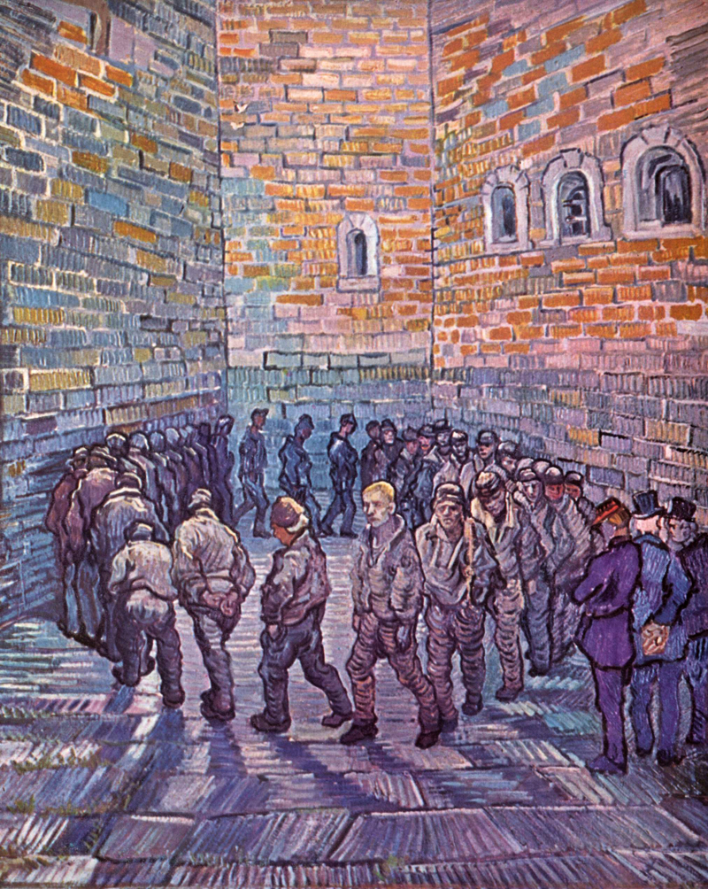
Prisoners exercising, Vincent Van Gogh, 1890
Sunday Worship at Historic Salem Church January 23, 2022
Order of Worship

Bell Ringing

Announcements
Call to Worship (All/Pastor)
This day is holy to the Lord your God.
Let us come ready to see, hear, and touch the Word of God.

Do not mourn or weep, and do not be grieved.
How can we be sad when we can experience God’s Word
and know God’s love through our worship together?
The joy of the Lord is our strength.
Let us come together to worship the God of joy, strength, and love.

Invocation

*Opening Hymn “Community of Christ” B # 314

Prayer of Confession (All/Pastor)
Loving God, we recall the times when your Word feels distant,
and when we forget how much you love us.
We let our egos take hold, and we treat others as threats to our sense of self.
We forget your words of comfort, love, and care.
We forget to look to your Word for guidance.
We forget that you are our ultimate source of joy.
Forgive us, O God.

Assurance of Grace
The Holy One’s instruction is perfect, reviving one’s very being.
God’s laws are faithful, making naive people wise.
God’s regulations are right, gladdening the heart.
God’s commands are pure, giving light to the eyes.
Know that you are loved and forgiven.
Thanks be to God.

Passing the Peace: May the peace of the Lord be with you. And also with you.
Hymn “The Body Is One” SPP # 36
Scripture Reading 1 Corinthians 12:12-31a Pew Bible, NT p. 174
Gospel Reading Luke 4:14-21 Pew Bible, NT p. 61
Message Pastor Mark Harris
Hymn “Forward through the Ages” B # 377
Pastoral Prayers, and Lord’s Prayer
Our Father, who art in heaven, hallowed be thy name. Thy kingdom come. Thy will be done on earth as it is in heaven. Givs this day our daily bread, and forgive us our debts as we forgive our debtors. And lead us not into temptation, but deliver us from evil. For thine is the kingdom, and the power, and the glory, forever. Amen.
Acknowledgement of the Gifts of the Body of Christ
Offertory
*Blessing the Gifts (together)
O God of all gifts, we join with Jesus in proclaiming the year of your favor.
Bless our gifts and bless us as we seek to bring joy and comfort to those who are unknown to us, and to those who are near and beloved. Amen.
*Congregational Thanksgiving “We Praise You, O God” B # 420 v. 3
With voices united, our praises we offer, and gladly our song of thanksgiving we raise. Our sins now confessing, we pray for your blessing; to you our great Redeemer, forever be praise!
*Sending Hymn “We Are All One” SPP # 121
*Benediction
*Threefold Amen Amen, Amen, Amen
Procession of the Light
The Year of the Lord’s Favor: Service Prayers for Epiphany 3 C was written by Debbie Gline Allen, Commissioned Minister of Christian Formation, who serves as Minister of Faith Formation for the Southern New England Conference, and as the Director of its Faith Formation Leadership Program. Copyright 2022 Faith INFO Ministry Team, United Church of Christ, 700 Prospect Avenue, Cleveland, OH 44115-1100. Permission granted to reproduce or adapt this material for use in services of worship or church education. All publishing rights reserved.

Historic Salem UCC Announcements for January 23, 2022
324 Walnut Street (P.O. Box 429) Columbia, PA 17512
Phone: 717-684-6498; email: salemucc.columbia@gmail.com;
Web: https://www.historicsalemucc.org/
Pastor: Mark Harris Executive Council Chair: Peggy Rupp
Exec. Cncl Co-Chair: Scott Bollinger Music Facilitator: Steve Spiese
Financial Secretary: Karen James Church Secretary: Peggy Spiese
This Week’s Coming Events
Sunday, every 10:15 – 11:15 am Worship Service
11:15-Noon Fellowship Hour (bring goodies to share)
Mon-Thurs 3:00-5:30 pm Rivertown Pride Center open in Ed Building
Wed, Jan. 26 6:00-7:00 pm Yoga in the Ed Building - All are welcome!!
Thurs, Jan. 27 7:00-9:00 pm NA Meeting in Ed Building

Yoga Classes: 6:00 – 7:00 pm on Wednesday evenings in the Education Building. The cost is $5 per class, offered by Jen Hollinger to beginners or others who haven’t practiced yoga recently. Bring a yoga mat or towel, water and plastic bands if you have them.
January Mission of the Month is Hands Across the Street, an organization coordinated from Columbia Presbyterian Church. HAS seeks to be a grass roots organization that provides first-level assistance to the people of Columbia and the surrounding area who come seeking assistance toward a better life. Among the services provided are a soup kitchen, community meals, temporary shelter, a community food bank, and more. To become involved, phone 717-684-6271.

Open/Close – Karen James (Volunteers are needed for these tasks
Usher - Karen James If you would like to help,
Teller - Hilary Smith please contact Karen James)

